Targets met and major accomplishments since the preceding report
This sixth report of the Southside Youth Success Project: Pathways to employment for young men at risk of joining gangs (SYSP) will highlight achievements for the quarter three of the 2013 and plans for Quarter four of 2013.
Quarter 3 of 2013, continued with the work established in previous quarter. 30 young men from the Southside of Belize City were identified to form a part of Cohort III . Also, an additional 25 young men constituting cohort III joined the programme for training in in Self-Esteem Conflict Resolution Anger Management Independent Liking Skills (SCAIS) methodology of delivering life skills training developed by the Ministry of Human Development, Landscaping and repair of small machines as the major trade area. Literacy, swimming, sports, job preparedness skills, arts and crafts amongst others. Continuing from previous cohorts, stipend payments are staggered throughout the six weeks of training in which participants receive stipends of $25.00 a week to facilitate their attendance at the centre. Additionally, stipend of $50.00 per week is being paid to young men on apprenticeship. The young men continue to receive daily lunches to which a contribution of $1.00 per day is also charged from their stipends. Following from the behavioral and health related issues which affected the participants as a result of hunger, and based on the project’s board recommendations, the SYSP is formally provided meals daily to participants through its established feeding programme. This has significantly stemmed many of the issues that the Project Coordinator and team had to deal with.
Quarter 2, 2013 continued to build on the close relationship between the SYSP and the Ministry of Education. The Department of Youth Services continues to provide support to the project and coordinator in the implementation of the SYSP. Additionally, through the ministry assigned Social Worker, the centre continues to embrace a holistic implementation of the SYSP. The families of participants continue to be involved in the implementation of the SYSP along with other social partners. Home visits have addressed the needs of family members of participants thus alleviating their worries to take care of their families and allowing them to focus on the training at the SYSP. In partnership with social partners, three parents were placed on an Entrepreneurship Programme for Women. These parents are learning how to sew and at the same time collect a small stipend of a hundred dollars a week. Additional families of trainees were placed on the BOOST and Food Pantry Programme. Grief and Loss Counseling sessions were solicited through the Cleopatra White Clinic for one trainee and his younger siblings as they recently suffered the loss of their mother. The SYSP continues to embrace its holistic approach to impacting the lives of young men from the Southside Belize City. The SYSP also solicited assistance from one law firm who has taken on a case for one trainee pro bono. Additionally through the SYSP, 13 participants were able to get registered and secure social security cards. These participants possessed no legal identity prior to enrolment at SYSP. Three parents were also able to become legally registered and are awaiting receipt of social security cards. This holistic approach is paramount to achieve a fully productive citizen and facilitates formal economic participation for participants when they have completed their five months at the SYSP. This coordinated pro-social approach at the centre has proven successful in maintaining a low dropout rate.
All participants of SYSP’s Cohort II were successfully placed on apprenticeship at the following locations: The Karl Heusner Memorial Hospital, The Princess Hotel and Casino, The National Post Office, Bottom Dollar, Belize Red Cross, Belize Defense Force, Action 1 Plumbing and Young’s automotive. Whilst of apprenticeship, participants attended a feedback session was held at Banana Bank Lodge where the participants highlighted their likes and dislikes of the programme. The participants also did community service on their way to their retreat venue by cleaning the grounds around the Youth Hostel and National Cadet. The participants indicated the satisfaction of being able to contribute meaningfully to Belize.
The project was able to secure nationally recommended software for the literacy and numeracy through a national licens. In an effort to target individuals and communities who are unable to be integrated into the formal economy as a result of a lack of literacy and other social issues, RESTORE Belize embarked on the provision of this literacy services to marginalized communities in Belize to stem inter-generational link between the literacy levels of parents and their children. Through the collaboration with the Centre for Family Literacy in Alberta, Canada, the literacy software endorsed by the literacy unit of the Ministry of Education and in use throughout the Caribbean was procured on behalf of the SYSP in June 2013 and will address the literacy needs of participants of the SYPS in an individual focused manner.

The SYSP was proud to introduce “The Good, THE BAD, The Nobody Road”, a compilation of stories of young men participating in the SYSP in QII 2013. The writer Myrna Manzanares, expressed great fulfillment in being involved in the documentation of these young men’s experiences, the stories of how they managed to rise above the challenges they face and survive. Minister of Education, Youth and Sports, Honorable Patrick Faber, who made the keynote remarks, commended the young men who have participated in the programme and contributed their stories. The book contains the reflections of the second cohort of young men. These stories provided a platform for these marginalized youth to relay their stories and gave account of their interaction with the state, the police, family, school and their communities. The rationale for highlighting the stories was twofold. It is first, to give voice and space to a group who often lack access to positively participate in public discourse on the issues that affect them. Second, it is to link preventing violence and/or reinforcing the underpinning assumption that youth can be a force for peace. The book was distributed by UNDP Assistant Resident Representative and Joseph Boski of the US Embassy.
The project has also embraced a rolling recruitment strategy; therefore a list of participants is being identified to form of the final Cohort of the CARSI SYSP. The project continues to extend its reach to Belize City and has received referrals from the family court and other social partners.

Anticipated accomplishments for next quarter
Additional young men from Southside Belize City will continue training in employability and life skills competencies in the next quarter. Quarter III 2103 will ensure that more young men are trained in specialized trade areas especially those which can observe apprenticeship placement. Additionally, drug abuse counseling, sexual and reproductive health training, other areas of counseling, sports and mentorship will continue to be simultaneously delivered.
Cohort III will then continue onto apprenticeship placement while keeping in close contact with the Drop in Centre. Therefore Apprentices will be monitored by assigned staff of the Centre and training in life skills and literacy will continue at the centre even while participants of Cohort III are on apprenticeship.
The project will continue strengthening its networking efforts among sector partners in order to make referrals for a continuum of care and support as needed by the young men. At the management level, the program continues its focus on building the institutionalization of the center as part of the youth development efforts in Southside Belize City.
Challenges/hindrances/concerns
There were a few hindrances experienced in quarter II 2013 as detailed below. Few behavioral issues surfaced in QII 2013. However the hand’s on approach of the new centre manager has resulted in a decrease on many of the behavioral issues encountered in 2012. Issues with finalizing apprenticeship placements proved most problematic; however the dedicated work of project staff resulted in placement of all participants of the SYSP.
With the opening of the rainy season, the centre now has to readapt to flooding during heavy rains. This issue is not easily ameliorated because of structural issues at the commercial centre. However, contingency plans for drying up flood waters and resuming training is being instituted.

Project Budget

South Side Youth Success Project: Pathways to Employment for Young Men At-Risk of Joining Gangs: Financial Report
Grant #: S-BH200-11-GR-010
Reporting Period: |  | 01/01/2013
Grant Period:to6/30/2013 | 10/1/2011 | to | 9/30/2013

Line Item | Award | Spent to Date | Remaining
Project Coordinator | 20,586.49 | 0.00 | 20,586.49
Local Consultants (Trainers and Counselors) | 25,666.49 | 6,237.00 | 19,429.49
Travel | 8,725.00 | 945.00 | 7,780.00
Contractual Services | 22,750.00 | 2,266.00 | 20,484.00
Communication and audio-visual equipment | 675.00 | 1,768.00 | (1093.00)
Supplies | 1,350.00 | 410.00 | 940.00
Information technology equipment | 1,000.00 | 6,113.00 | (5,113.00)
Indirect Costs (Facilities and Administration) | 7,215.00 | 0.00 | 7,215.00
Grants(Stipends) | 25,280.00 | 5,621.00 | 19,659.00

Project Photos
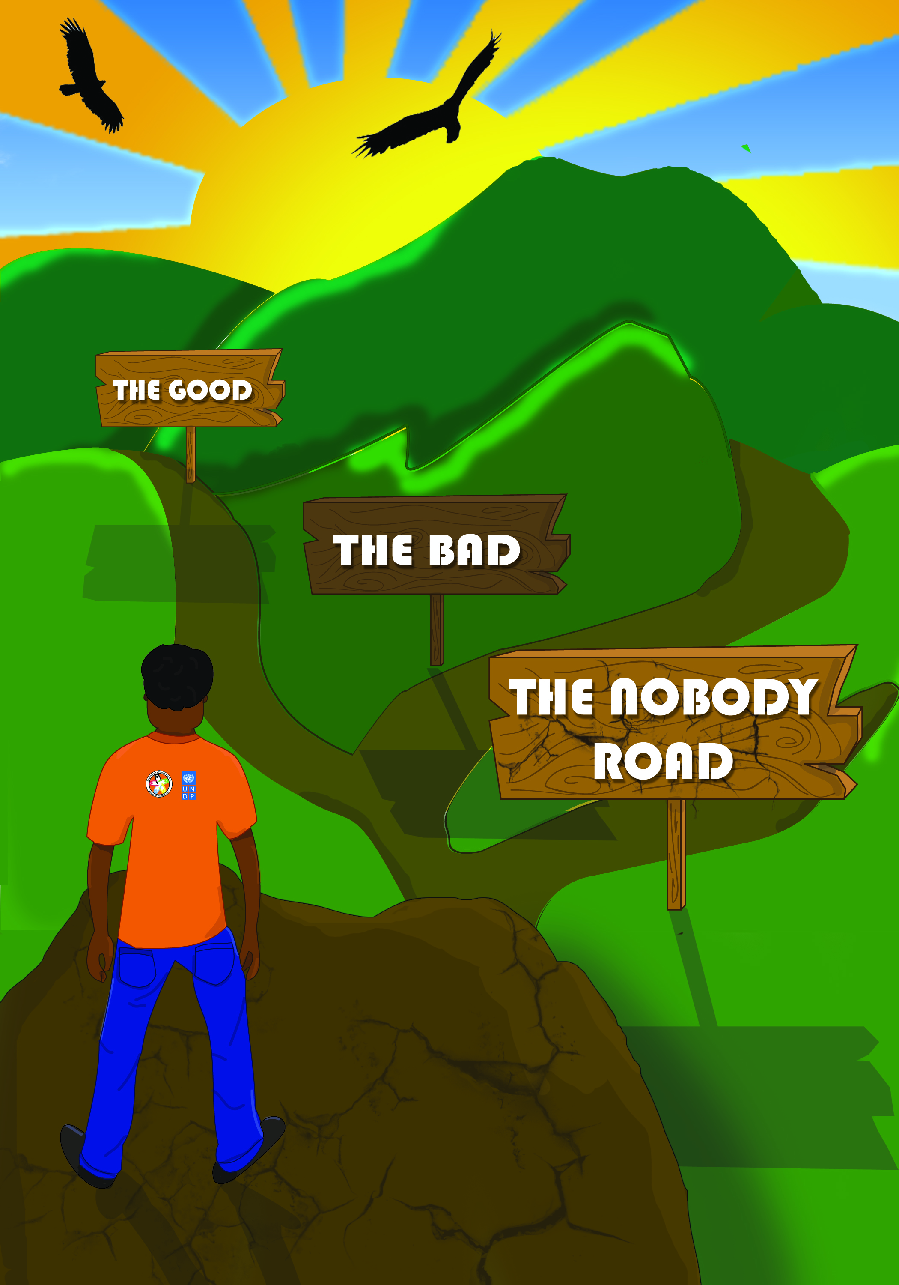 Publication: The good, The Bad, The Nobody Road

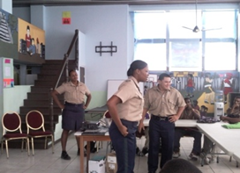 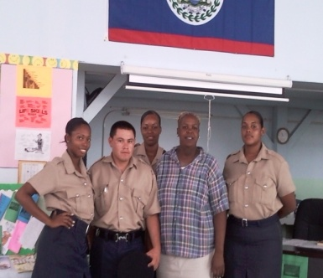 Participants interact with Police Department

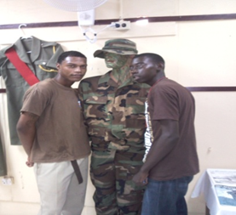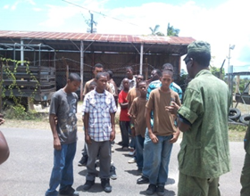 Participants also interact with the BDF

SYSP COHORT II TRAINEES ON APPRENTICESHIP

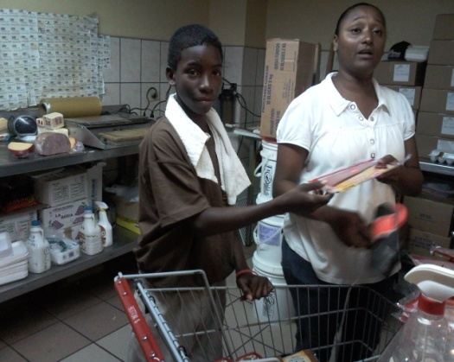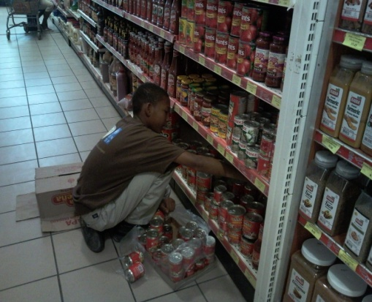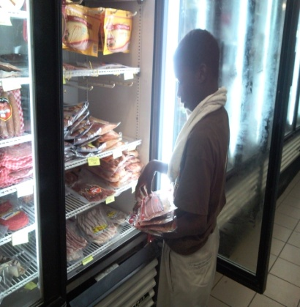

Trainees conducting apprenticeship at Bottom Dollar

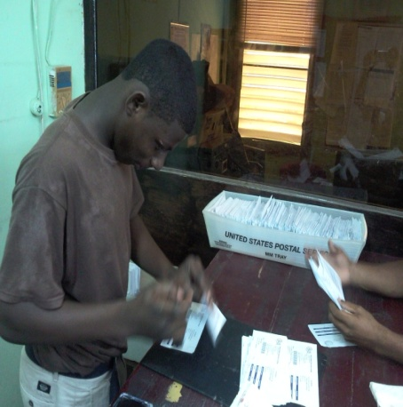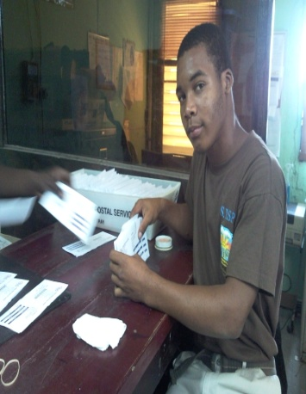

Trainee conducting apprenticeship at Belize Postal Service

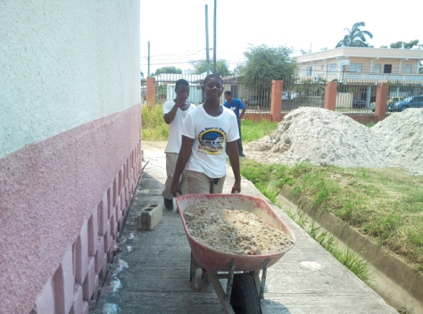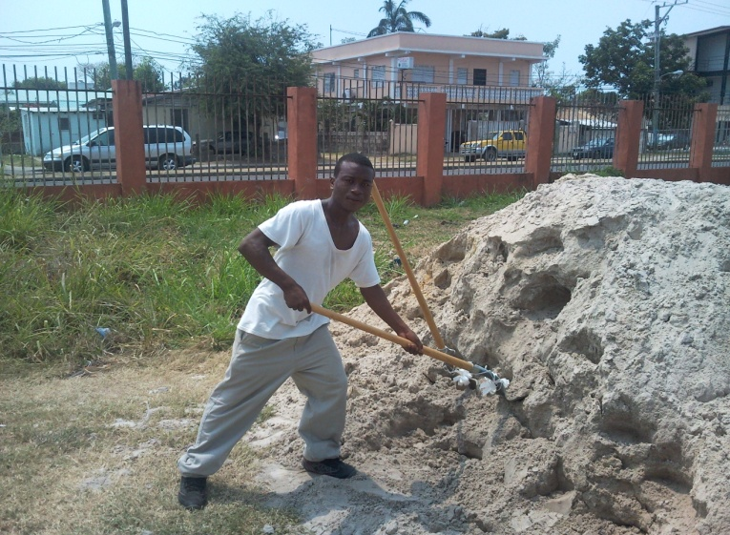

Trainees on Apprenticeship at the KHMH

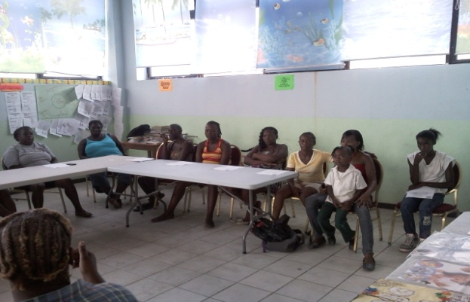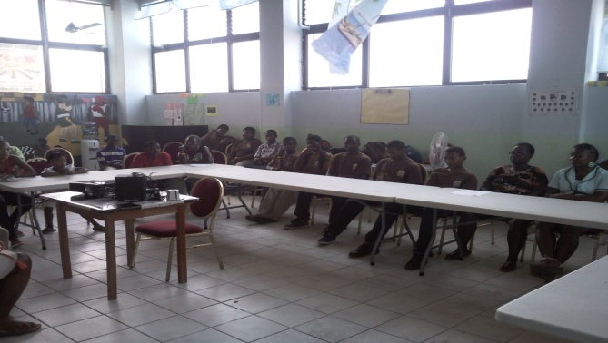
Parents of SYSP participants are actively involved

